**Deep Learning Mini-projects [ Lai,Ying-Ru & Chen, Hong-Guai ]**

# **Project 1 – Classification, weight sharing, auxiliary losses**

## [ Method 1 ] Compare the accuracy between two inputs trained on the same model with weight sharing and of the use of an auxiliary loss, and two other models trained separately without weight sharing and of the use of an auxiliary loss.

* Accuracy of digit prediction
  + Trained on the same model with weight sharing and of the use of an auxiliary loss : **95.2%** [Better]
  + Trained on two separate models: **92.8% & 93.7%**

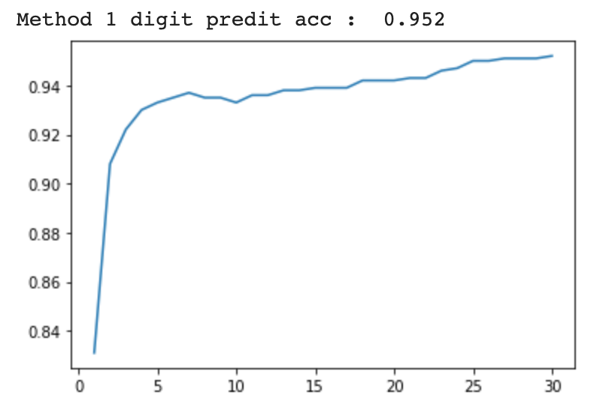 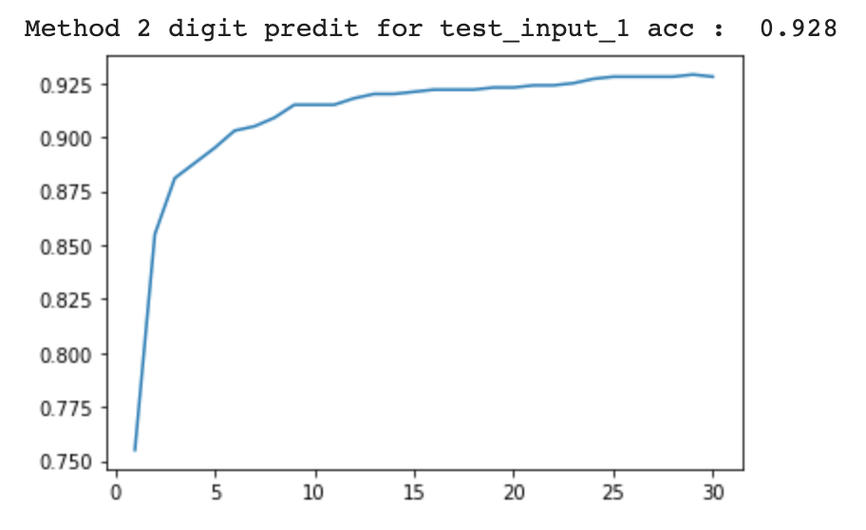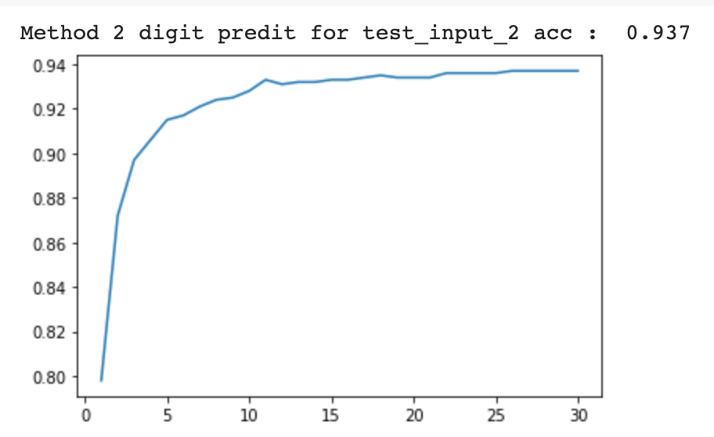

* Accuracy of target and predicted output ( i.e. for each pair, if the first digit is lesser or equal to the second) :
  + Trained on the same model with weight sharing and of the use of an auxiliary loss : **96.5%**[Better]
  + Trained on two separate models: **95.3%**

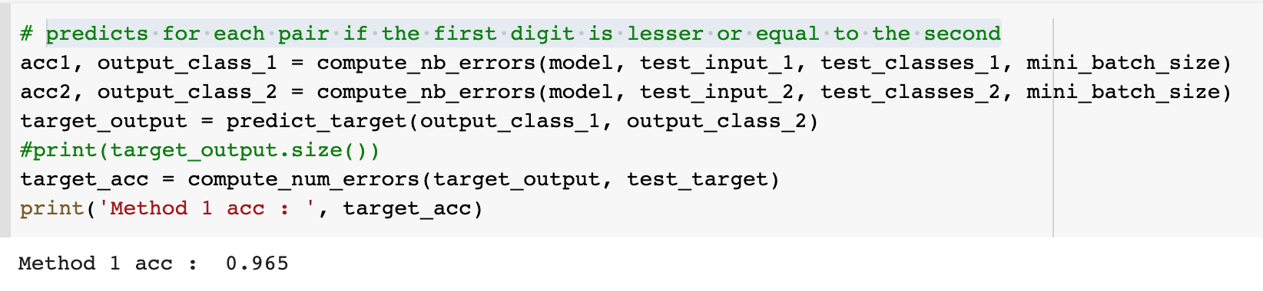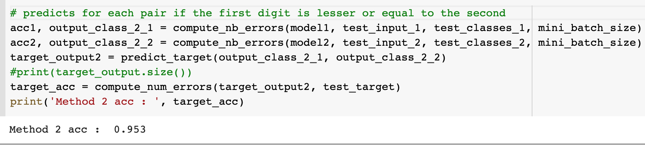

## [ Method 2 ] Compare the accuracy and parameters usage between training on MLP and CNN(which with weight sharing and of the use of an auxiliary loss)

* **Accuracy of digit prediction**
  + MLP: 90.4%
  + CNN : 96.5% [Better]
* **Total parameters usage**
  + MLP: 414.418
  + CNN : 341,026 [Better]

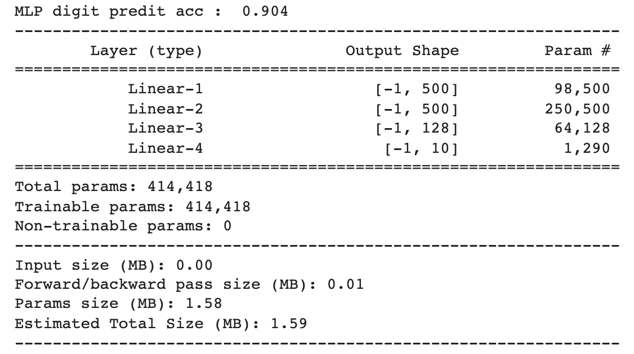 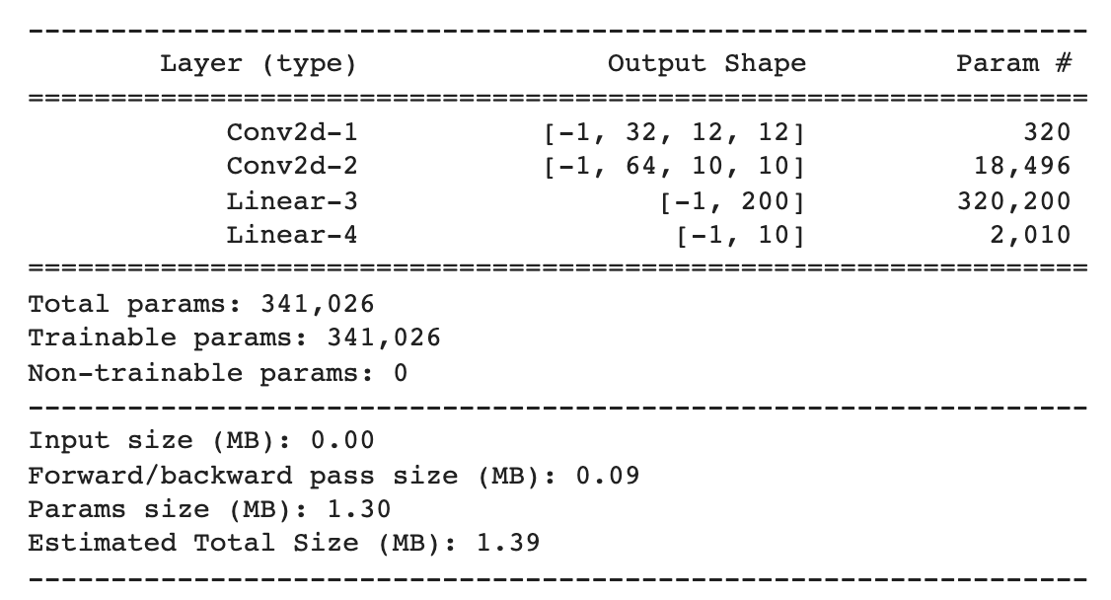

# **Project 2 – Mini deep-learning framework**